Response to change

Template

Please complete this section of the template before doing the research.

Step 1:

Think of two change experiences you have recently experienced and on the template provided, provide an overview of what the change was.

1. A change imposed upon you – where you felt like you didn’t have a choice in the change. It can a be a small or large change; gradual or sudden; expected or unexpected.
2. An intentional change where it was a conscious decision by you to initiate or support a change.

|  |
| --- |
| Change that was imposed on me:  I am working on improving my cgpa at college. And this seem coming true I got more marks in mst from last year but this covid-19 change every thing. |
| Change that was intentionally generated by me:  After holiday(or lock down) I feel that everything I have done is useless more than half of semester is gone in holiday. A news from ugc and my university that they are not going to conduct the semester exam will take my work to sewage. University give a consent form(Even semester marks is being uploaded) nothing ca be done. |

Step 2:

Think about and record the range of reactions you experienced (mindset/emotions and behavior) as you went through the changes – from the beginning to the end.

|  |
| --- |
| The range of reactions experienced for the change that was imposed on me was:  When I was first told that I was getting a new manager, I felt anxious as I didn’t know the person and  I was really upset about losing my old manager. I liked and respected my old manager. This new  manager had big shoes to fill! My expectations were very high, and I wasn’t happy about the  change. When the new manager started, I felt that they didn’t like me and were nothing like my old  manager. It was hard and I felt demotivated as they managed me in a totally different way and didn’t  seem to trust me at all. I tried to show them how capable I was, but they just gave me endless tasks  to do and never praised me for the tasks I was doing well. After feeling frustrated and angry, I asked  for a meeting with my manager and told them how I felt. This was a very scary thing to do and it  took a lot of courage. I was nervous. They were shocked by what I said as my manager had no idea  about how I was feeling and what I needed to help me be successful and happy at work. We agreed  to work out a plan for the way forward and how to make it work for us both. I felt hopeful after that  meeting and proud of myself for having a constructive conversation about this. We slowly began to  improve our relationship and now we have a very positive working relationship and I am back to  feeling motivated at work. |
| The range of reactions experienced for the changed that I intentionally generated was:  I was nervous making such a big decision to change my course and I even felt like I was letting  people down and had failed. But, as soon as I made the decision and the process to change courses  started to happen, it was like a weight lifted from me and I was so happy to start my new course – I  was excited about the future. I did have a few moments where I was worried, I’d made the wrong  choice, but it turned out to be the correct choice and now I’m coming to the end of my course and I  know I made the right decision. |

Step 3:

Complete the reading and research in the additional resources to get a better understanding of ‘why’ you experienced what you did and then complete the next page.

Step 4:

Now that you’ve done your research about the Change Curve, please complete the final section. Here is a reminder of the Change Curve:

The Kübler-Ross change curve

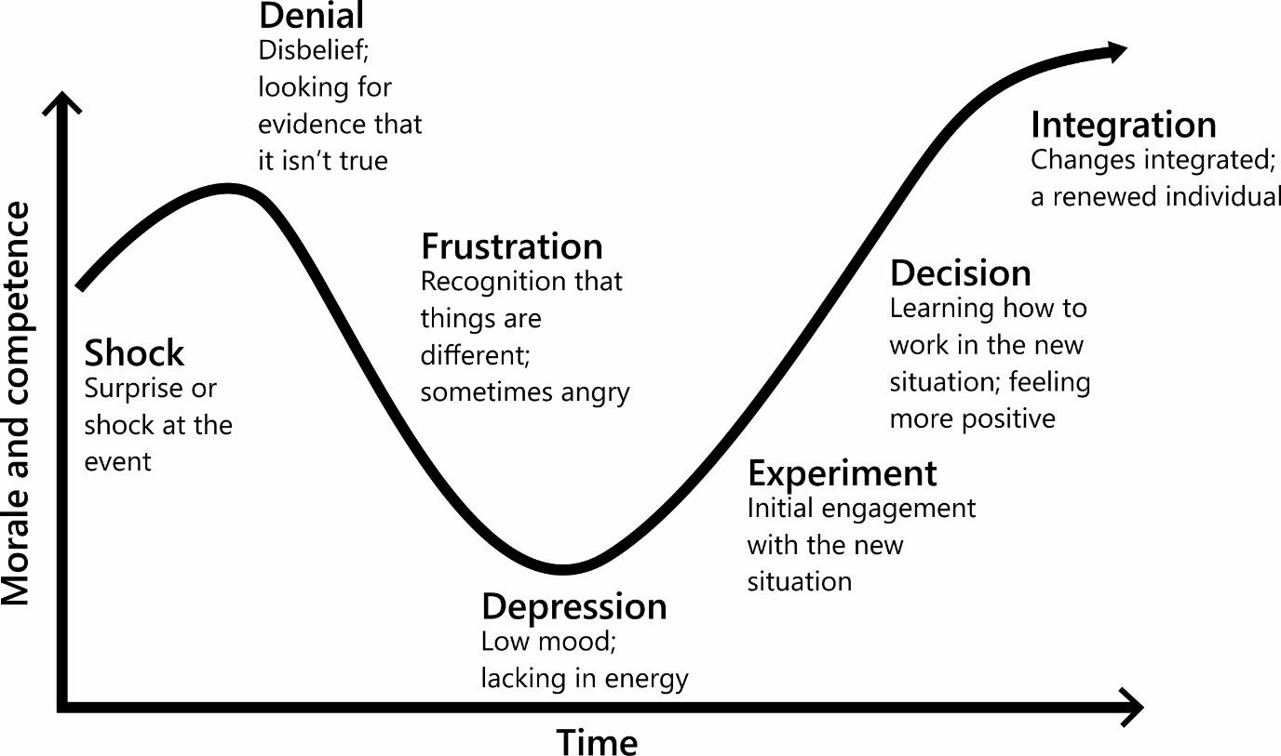

Step 5:

Identify what you have learnt from reflecting on this experience. Thinking back to the changes you wrote about earlier, identify what you have learnt from reflecting on this experience. It would also be beneficial to detail what happened at each stage of the Change Curve for you.

|  |
| --- |
| My reflections and learnings for the change that was imposed on me:  I learnt that I need to speak up when things aren’t going right for me, to ensure there is an  opportunity to put it right.  Shock: I now understand that I was in shock when I was first told that my manager was not going  to manage me anymore. I really didn’t expect it.  Denial: I definitely had a moment of denial, as I was so upset about losing my manager that I just  didn’t want to accept that it was happening.  Frustration: I got very frustrated and I think I stayed at this stage for quite a while, as I just couldn’t  see a way forward from this. It also made me angry with how I was being managed and I found this  difficult to cope with – everything had changed, and I really didn’t like it. I felt like my career  development was being negatively impacted by someone else.  Depression: I definitely recognize that my motivation dropped, and I didn’t have the same energy  as I used to. In reflection, this may have been part of the problem, as perhaps this meant that I  wasn’t performing as well as I used to, so the new manager didn’t know my capabilities. I also think  I possibly didn’t make it easy for this new manager as I was continuously comparing them to my old  manager. I didn’t really give them a proper chance to begin with or see how this change was also  difficult for them. I didn’t start the relationship with an open mind as I just wanted them to replace  my old manager and keep everything the same.  Experiment: I asked for a meeting with my new manager to talk about how they were making me  feel. I think this was me trying to engage with them and find a better way of working. I was close to  leaving the company but decided to try this approach first. It really was a bit of an experiment, but  it paid off. |
| My reflections and learnings for that change that I intentionally generated:  **I learnt that I need to trust my own judgement and believe in myself.**  **Shock: I was aware that I was on the wrong course and felt a bit surprised by the fact that I’d made**  **such a wrong decision for myself in the first place. I wasn’t sure at first if I could change course or**  **what I could possibly do about it.**  **Denial: I remember thinking that I should stay on the current course, as I’d already put in so much**  **hard work and I didn’t think my family would be happy. I felt like I would be a failure if I didn’t stay**  **the course.**  **Frustration: I continued to feel frustrated with myself for making the wrong decision initially, as I felt**  **I had wasted time on the first course and I really wasn’t happy or motivated anymore. I started**  **procrastinating a lot!** |

Any final thoughts or reflections on how you could deal with change more effectively in the future?